

**HO CHI MINH UNIVERSITY OF TECHNOLOGY AND EDUCATION**

**FACULTY FOR HIGH QUALITY TRAINING**

**🕯✡🕮🕮✡🕯**



**IT PROJECT**

***TOPIC:* FASHION CLOTHING BUSINESS**

**WEBSITE**

***Instructor****: Ms Mai Anh Tho*

***Made by student****:*

1. *Cao Thai Dat 21110762*
2. *Tran Duc Quang 21110793*
3. *Tran Binh Phuoc 21110803*

Ho Chi Minh, Dec 2023

TABLE OF CONTENTS

OPENING MARKS 1

INTRODUCTION 2

DEVELOPMENT ENVIRONMENT 3

CONTENT 4

CHAPTER 1. DESCRIPTION OF SYSTEM REQUIREMENTS 4

1.1. Funtional survey 4

1.2. List of business function requirements 10

1.3. List of functional requirements 11

1.4. List of functional requirements 11

1.5. General use case diagram 11

CHAPTER 2. SYSTEM DESIGN AND IMPLEMENTATION 13

2.1. Model 13

2.2. Admin side 16

2.2.1. Views 16

2.2.2. Controller 18

2.2.2.1. Login Controller 18

2.2.2.2. Category Controller 19

2.2.2.3. Product Controller 21

2.2.2.4. Order Controller 23

2.2.3. Service 24

2.3. Customer side 24

2.3.1. Views 24

2.3.2. Controller 27

2.3.2.1. Account Controller 28

2.3.2.2. Cart Controller 28

2.3.2.3. Email Controller 29

2.3.2.4. Login Controller 30

2.3.2.5. Order Controller 31

2.3.2.6. Product Controller 31

2.3.2.7. Review Controller 33

2.3.3. Service 33

CHAPTER 3. GROUP CONCLUSION 35

3.1. Task manager 35

3.2. Pros and cons of the project 35

3.3. Chalenges and difficulties 35

REFERENCES 37

# OPENING MARKS

First of all, we would like to sincerely thank our teacher, Ms. Mai Anh Tho, for his dedicated guidance that has helped us complete the final report of this semester's course on IT Project. Thanks to the knowledge imparted by our teacher, we have gained a solid understanding of the fundamental concepts and foundations for building a database management system. Through this project, our group would like to present the development process of a database management system, as well as programming a related project.

During the course of this project, we may have made mistakes, and therefore, we greatly appreciate any feedback from our teacher to help us improve, develop, and make our work more comprehensive. We wish our teacher good health, happiness, and success in his teaching career.

# INTRODUCTION

In today's rapidly evolving Information Technology landscape, the internet has cemented its position as an integral part of our daily lives. Alongside this, the retail fashion industry has seen tremendous growth, and the incorporation of information technology into the management of online clothing stores has become an inevitable trend.

Imagine a modern web-based clothing store management system, where shop owners can efficiently oversee and manage their online store without needing to be physically present. With just a computer and an internet connection, this software provides convenience and flexibility in the management of the fashion boutique. Functions such as inventory management, sales analytics, staff supervision, and customer interaction are made simpler and more efficient than ever before.

However, to maximize the benefits of this clothing store management software, it is crucial to intelligently and efficiently build and maintain the underlying database. The database serves as the core of the system, housing critical information about products, customers, employees, and transactions. It is through this database that boutique owners can meticulously track and analyze data, enabling them to make informed and dependable business decisions.

With the potent capabilities of this web-based clothing store management software and its database, not only can the boutique owner exercise greater control and flexibility, but the Customers can also experience comfortable online shopping and selection that information technology brings. Nevertheless, it's essential to acknowledge that during the deployment and utilization of the software, challenges and errors may arise, especially in the coding and maintenance of the database. Therefore, to enhance our proficiency in constructing and effectively utilizing databases, we have chosen the topic of online clothing store management as the focus of this project.

We extend our heartfelt gratitude to Ms. Mai Anh Tho for her invaluable assistance in completing this project. While significant efforts have been invested, we understand that errors may surface in the process of compiling this thesis. We eagerly anticipate your feedback, which will undoubtedly aid in our continuous improvement for future endeavors.

We sincerely appreciate your support and guidance!

# DEVELOPMENT ENVIRONMENT

**IDE: IntelliJ IDEA 2021.1**

IntelliJ IDEA 2021.1 is a robust and user-friendly integrated development environment (IDE) that caters to a wide range of programming languages. It provides efficient and intelligent features such as code completion, refactoring, debugging, testing, and deployment tools. IntelliJ IDEA 2021.1 supports various languages, including Java SE, Java EE, and many others. This IDE is equipped with advanced capabilities to facilitate fast and smart code editing, making it a popular choice among developers.

**Server: Apache-tomcat-9.0.80**

Apache Tomcat 9.0.80 is an open-source web server and servlet container that implements the Jakarta Servlet, Jakarta Server Pages, Jakarta Expression Language, and Jakarta WebSocket specifications. It offers high performance, scalability, and integration with native server technologies. It also supports HTTP/2, TLS virtual hosting, and multiple certificate support. Apache Tomcat 9.0.80 is compatible with Java SE 8 and later versions.

**Java version: jdk-20.0.2**

JDK 20.0.2 is the latest update release of the Java SE platform. It contains security fixes, bug fixes, and performance improvements. It also includes IANA time zone data 2023c, which reflects the latest changes in daylight saving time and regional settings around the world. JDK 20.0.2 supports the development and execution of Java applications that use the new features and enhancements introduced in Java SE 20, such as sealed classes, foreign-memory access API, and vector API.

  

# CONTENT

# DESCRIPTION OF SYSTEM REQUIREMENTS

## Funtional survey

After consulted website Hades, SoVintage we got some highlight of thems:

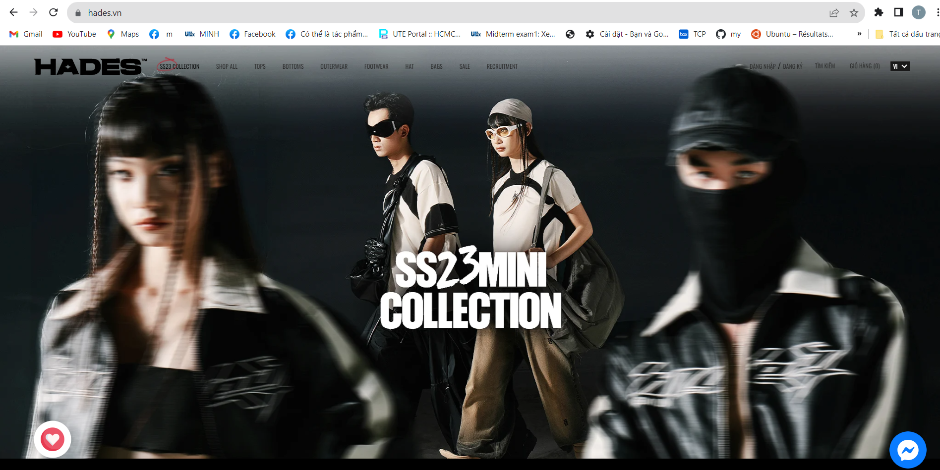

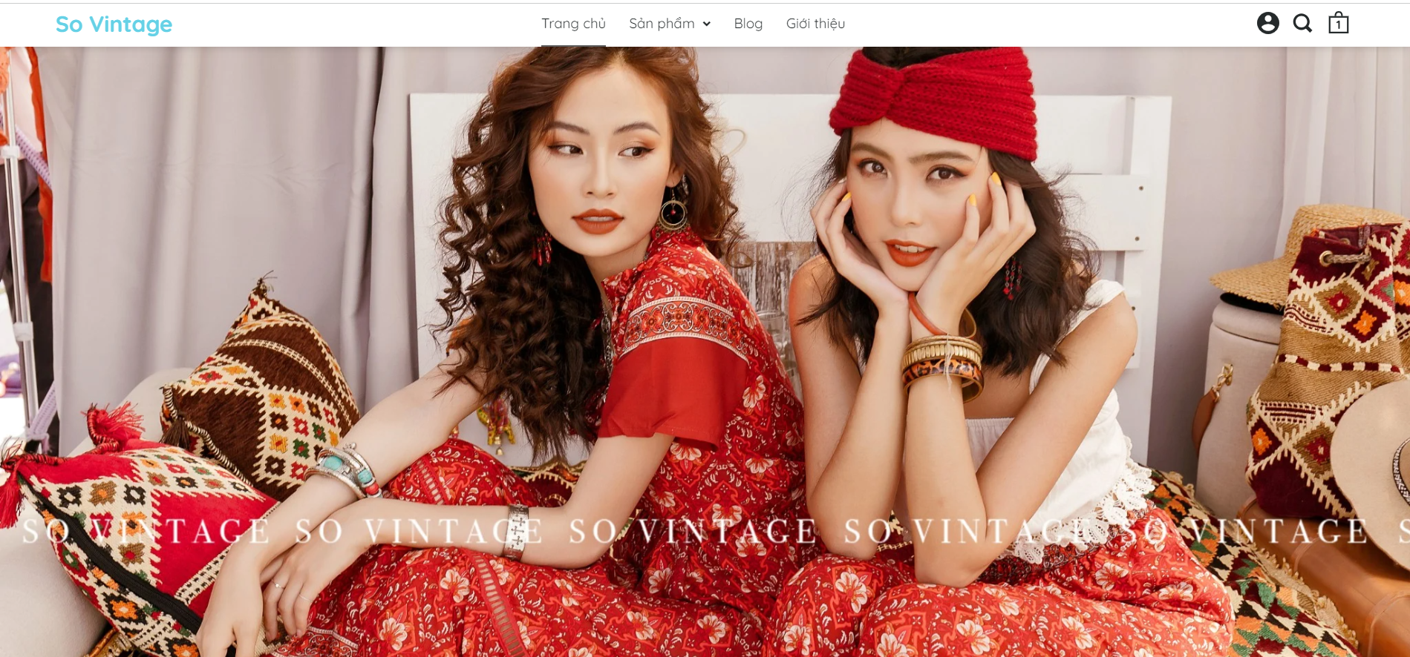

**Home page**

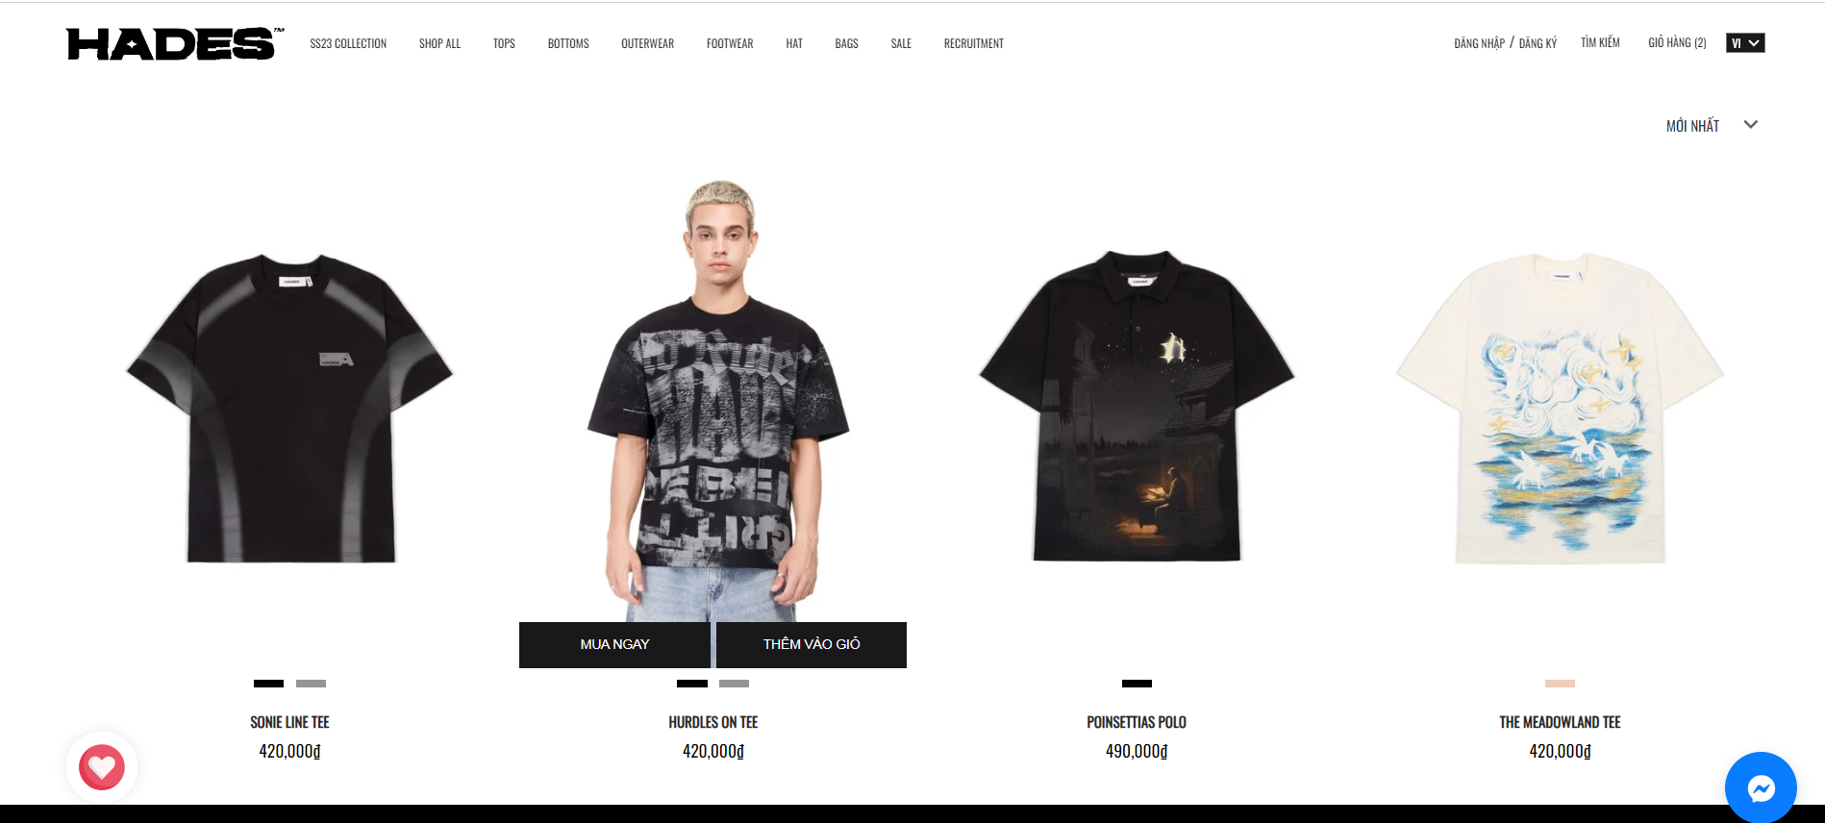

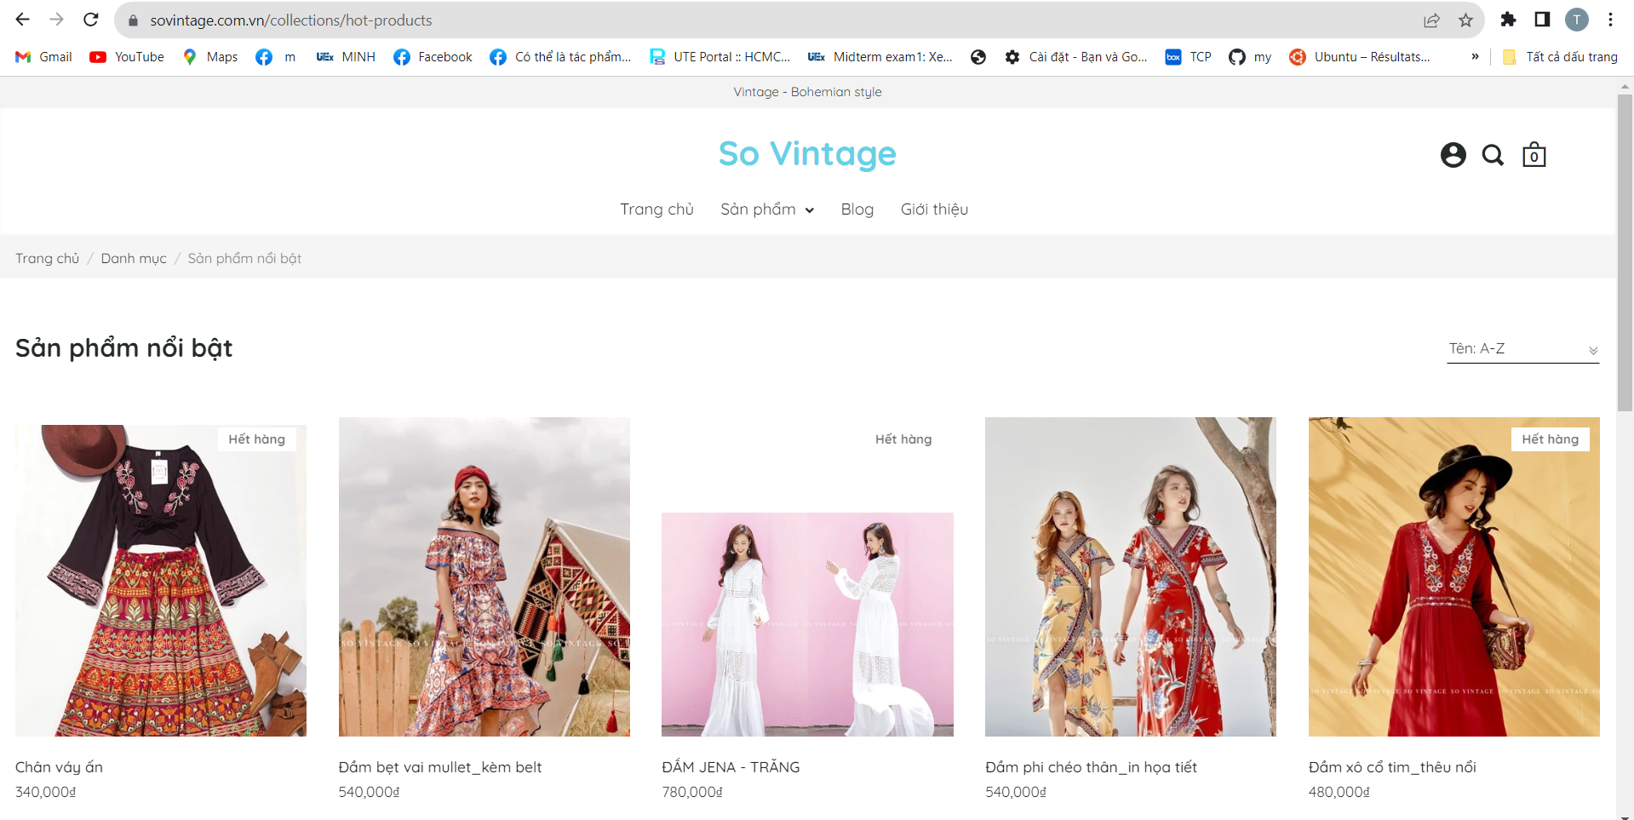

**Product Page**

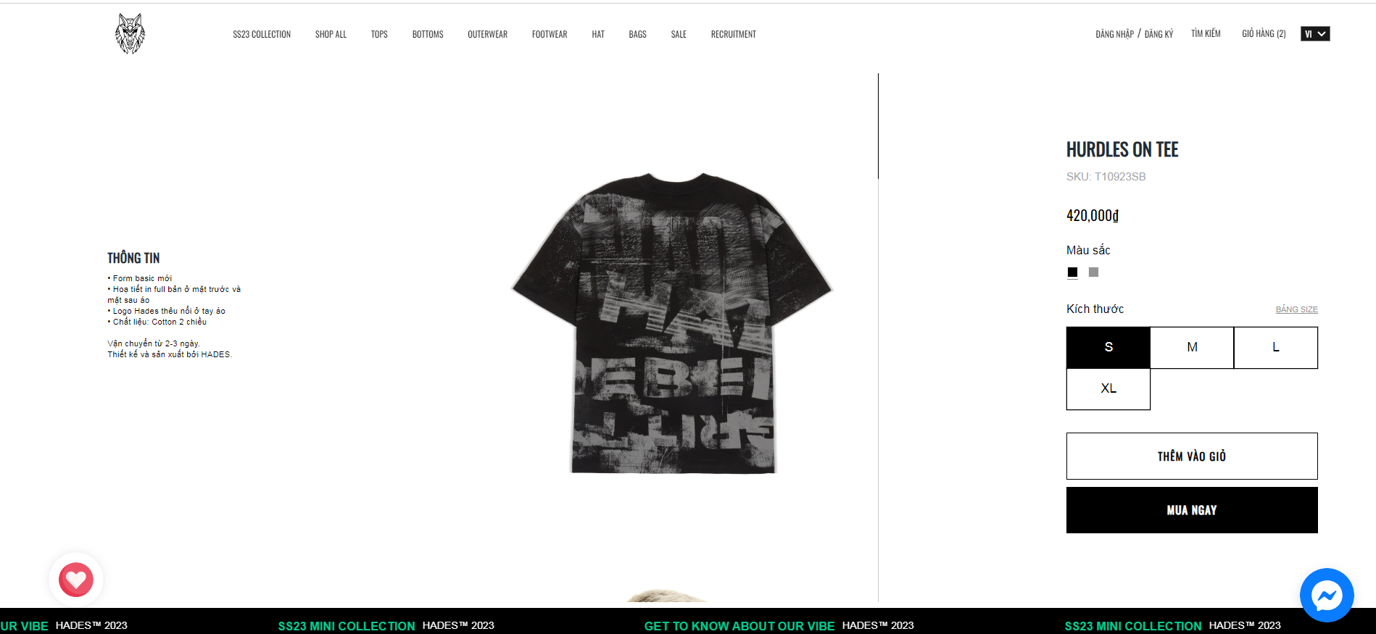

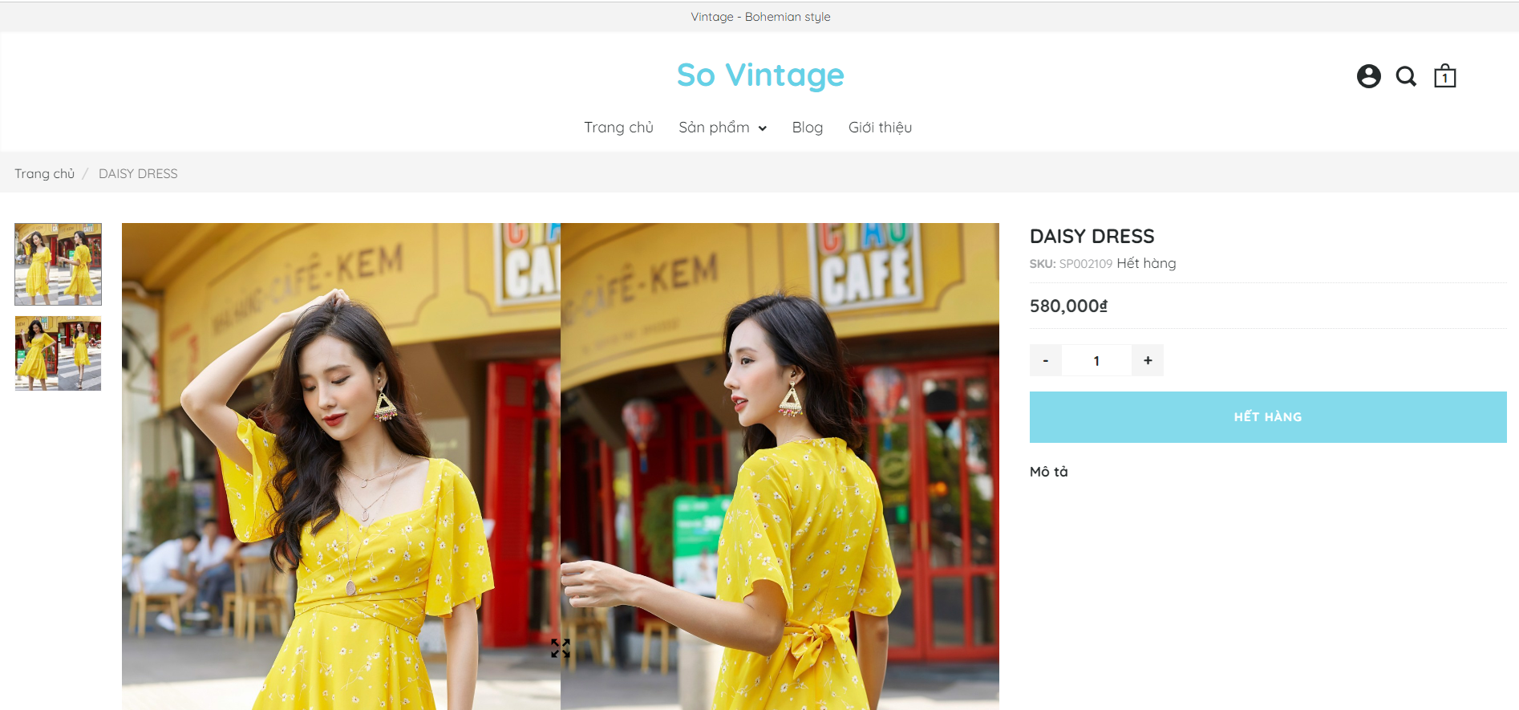

**Product Detail Page**

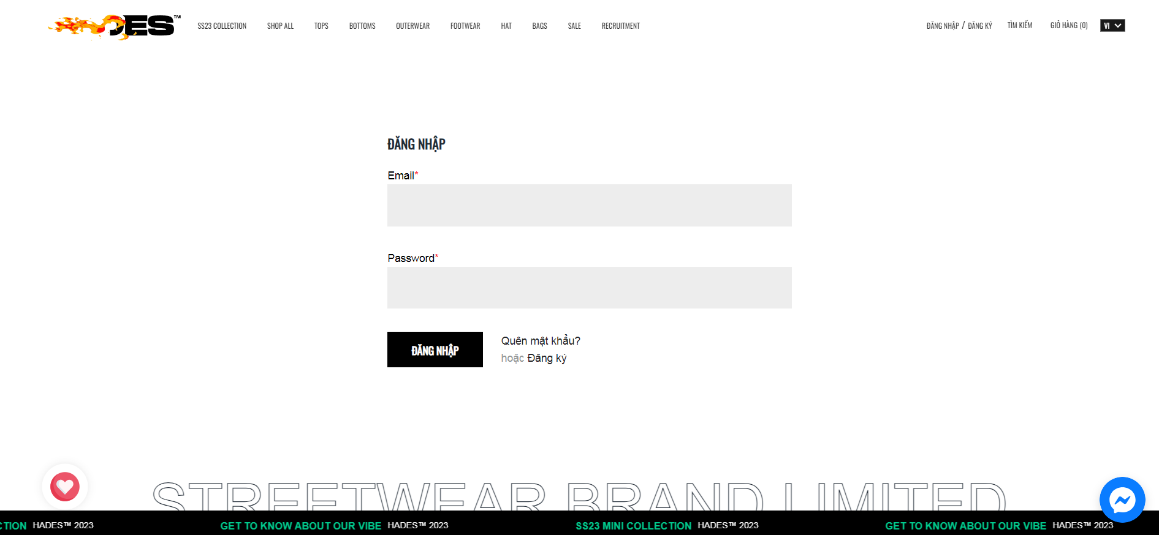

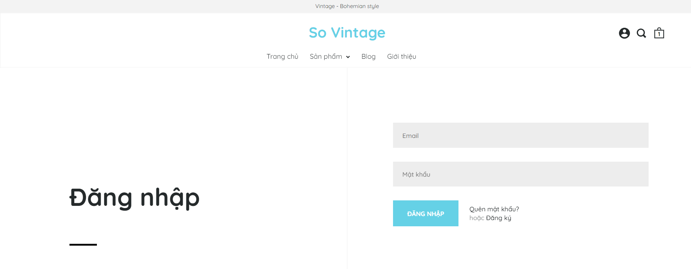

**Login Page**

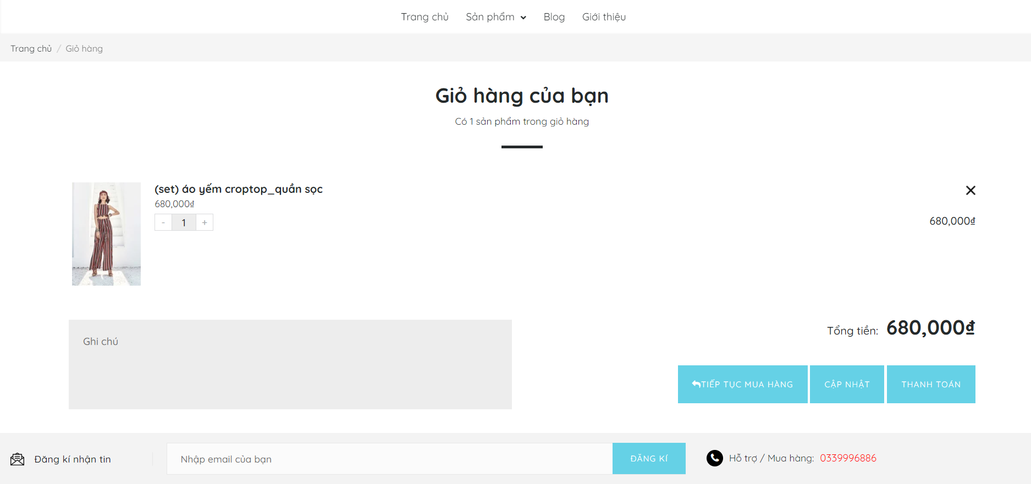

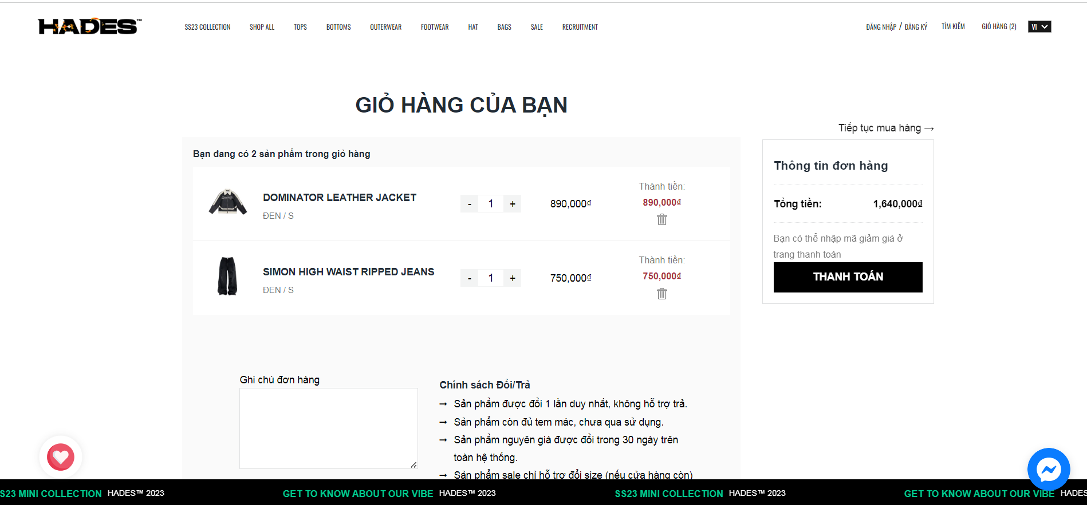

**Cart Page**

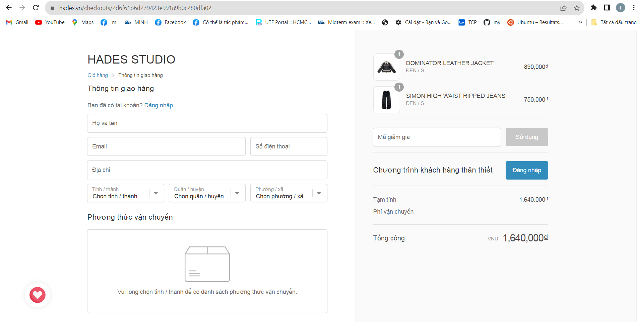

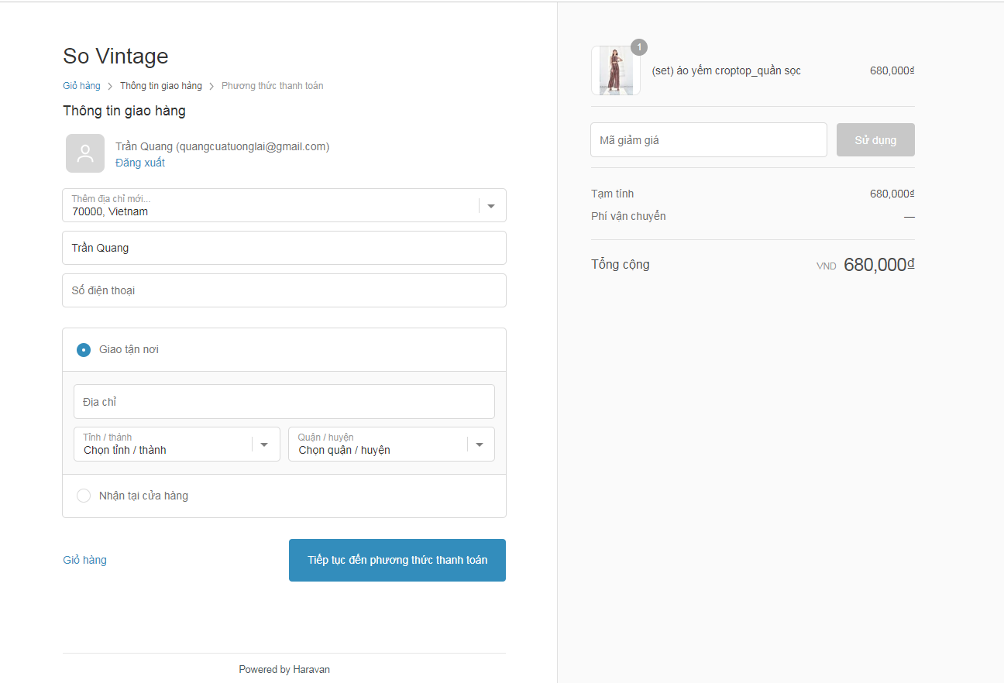

**Payment Page**

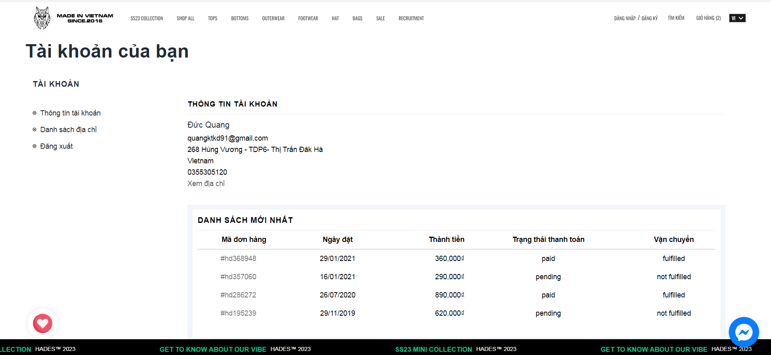

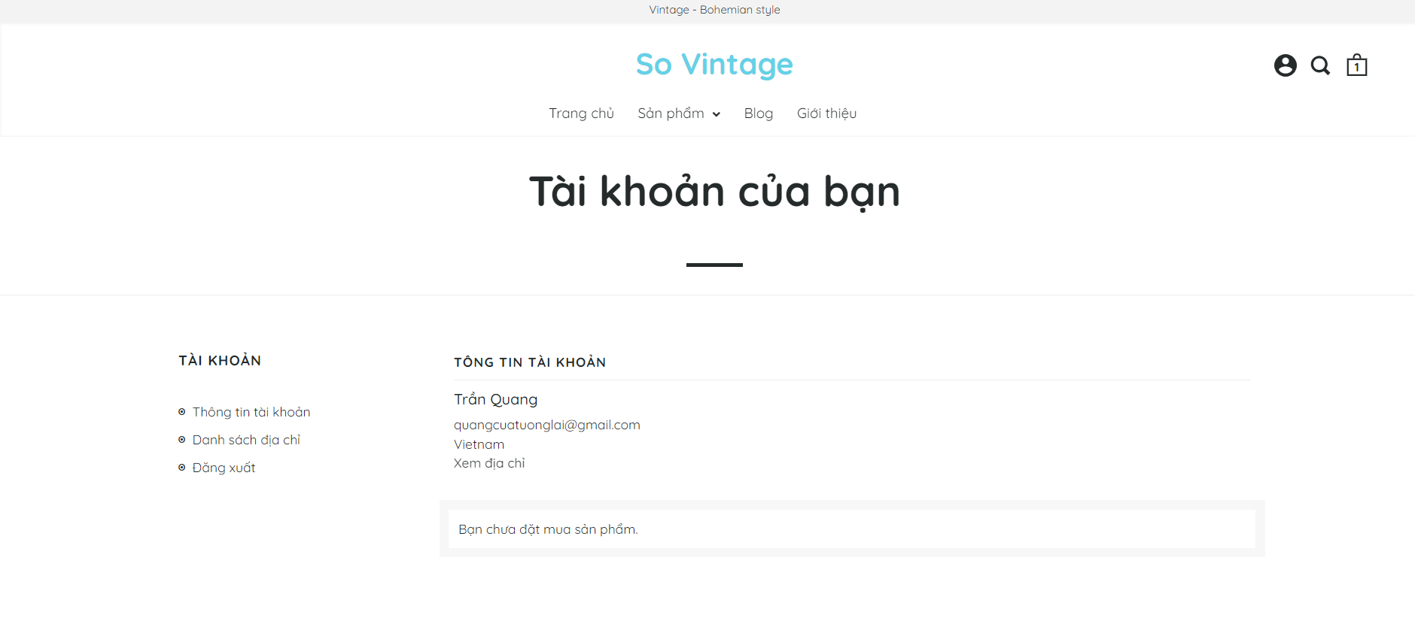

**Account Page**

After consulting the major websites above, we can summarize the basic functions in each page:

|  |  |  |
| --- | --- | --- |
| Page | Pros | Cons |
| Home Page  <https://hades.vn/>  <https://sovintage.com.vn/> | - User-Friendly Design, using interactive elements: buttons, forms, sliders, … creating enhance user engagement.  - Fast response speed. | The animation when clicking on a button are quite garish on Hades’s page, with Sovintage they’re display too much product on home page we can’t see what really stand out. |
| Product Page  <https://hades.vn/collections/all>  <https://sovintage.com.vn/collections/all> | - The product title, prominently displayed near the image, should be concise and descriptive, quickly conveying what the product is.  - Diverse products, each item displays the product's color palette. | With Sovintage the products are not really what they’re tagged to be. |
| Product Detail Page  <https://hades.vn/products/hurdles-on-tee>  <https://sovintage.com.vn/products/mandala-dress> | - Clear and Compelling Product Descriptions, High-Quality Product Images.  - There is a photo scroll that allows users to view different angles of that item. | Both of the webs are not showing their interactive features which is they don’t display the previous customer’s comment with the products. |
| Cart Page <https://hades.vn/cart>  <https://sovintage.com.vn/cart> | - Order information is concise, full of information, it serves as a quick reference point for customers.  - Has all necessary order adjustment functions for customers. |  |
| Payment Page | - Easy Checkout Process with simple checkout process simple, clear instructions and minimal steps.  - Offering multiple payment options. | - There is no user rating system for the product. |
| Account Page | - Intuitive and user-friendly, making it easy for users to understand how to log in.  - Allows users to recover their accounts if they forget their passwords, enhancing user convenience. | - Managing personal information is simple  - Address management is limited. |

**Table of functions and limitations of Hades & So Vintage**

We can refer to the highlights of the web beside those basic function (login, payment, search, …) such as:

- User friendly navigation: user can easily find the products or information they are looking for as the design style of these web are minimalism. But sometimes their categorize may be too details make user confused.

- Products are sorted by group or by collections help user are easily to find the style that they are into.

## List of business function requirements

* Product Management:

**-** Display products by type

**-** Search for products

**-** Filter products

**-** Images and product information

* User management:

- Log in

- Register

- Payment orders

- Cancel orders

- Account management

- Add reviews

- Purchase history

* Pay:

- COD payment

- Stripe payments

## List of functional requirements

**-** Add, delete, update products.

- Update order status.

- Add, delete, update users.

## List of functional requirements

**-** The system has security and decentralization functions.

- Passwords and sensitive information of users are encrypted before being written to the database.

## ­General use case diagram

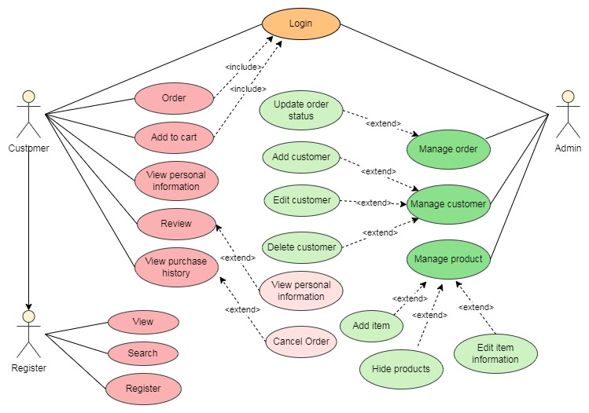

Detailed description of the actors:

|  |  |
| --- | --- |
| Agent name | Function |
| Non-Register Customer | - Regist  - View product information  - Search product |
| Customer | - Regist - Log in  - View product information  - Search product  - Order  - Add product to cart  - View personal information  - Product reviews  - View purchase history  - Password Recovery |
| Admin | - Log in  - Manage order  - Manage product  - Manage customer  - Manage product reviews |

# SYSTEM DESIGN AND IMPLEMENTATION

## Model

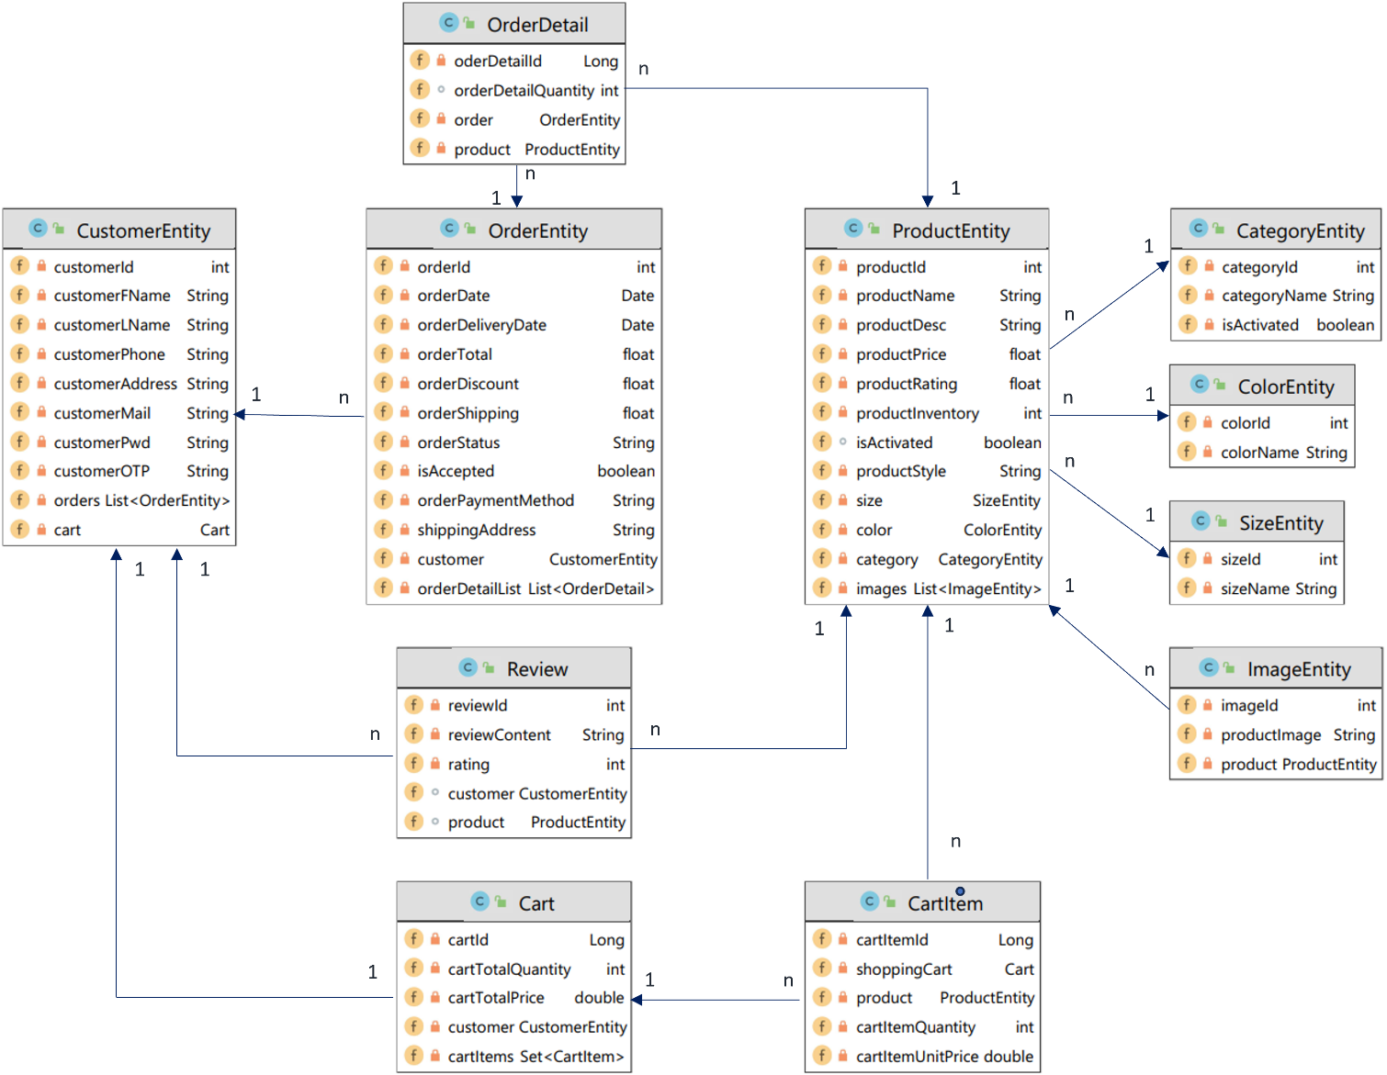

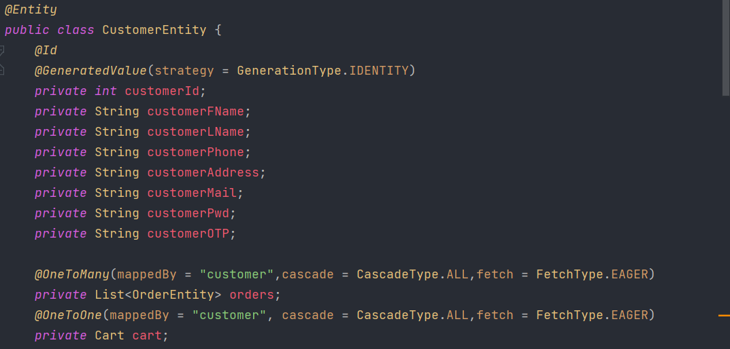

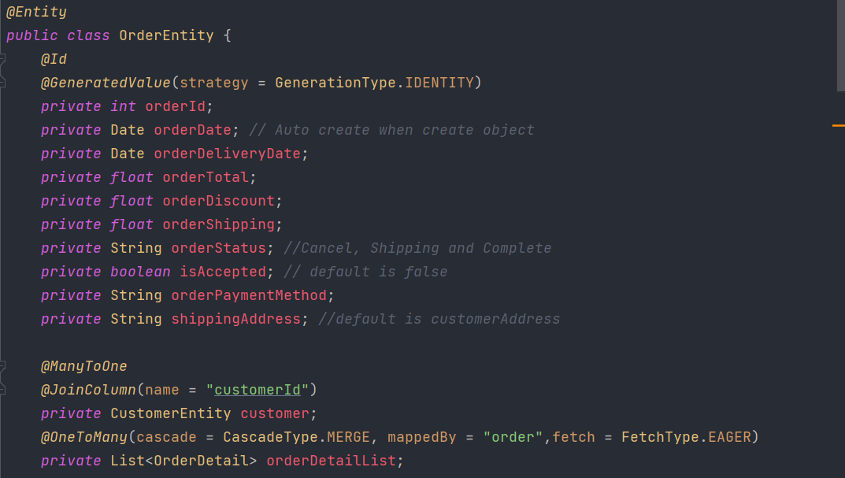

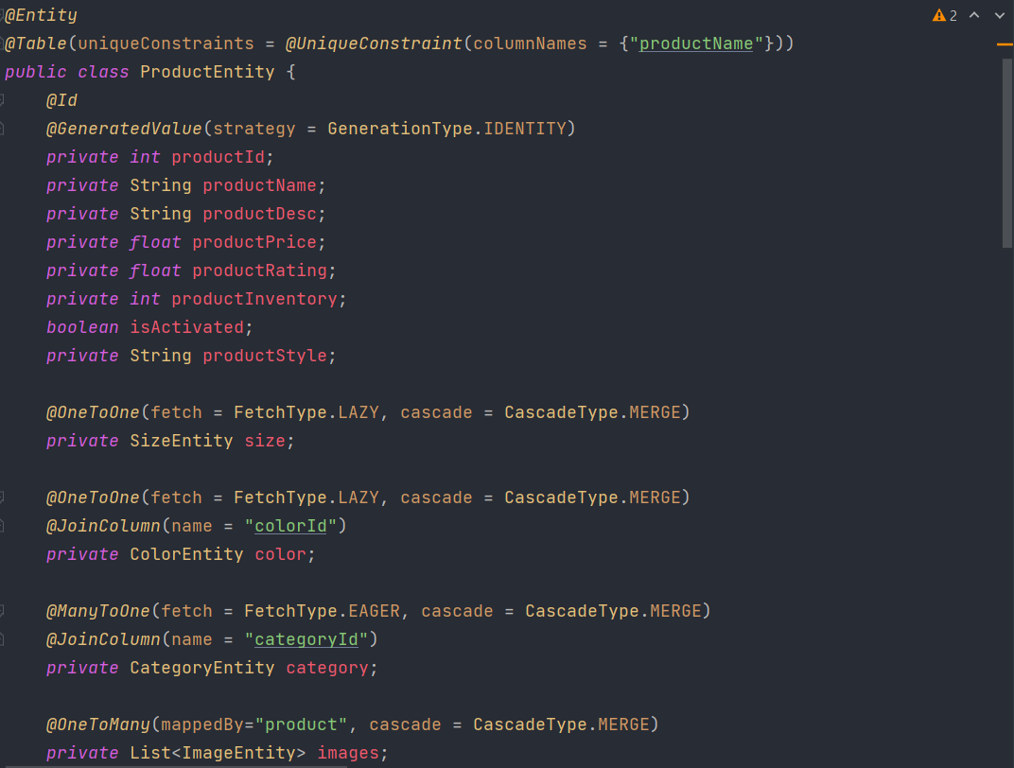

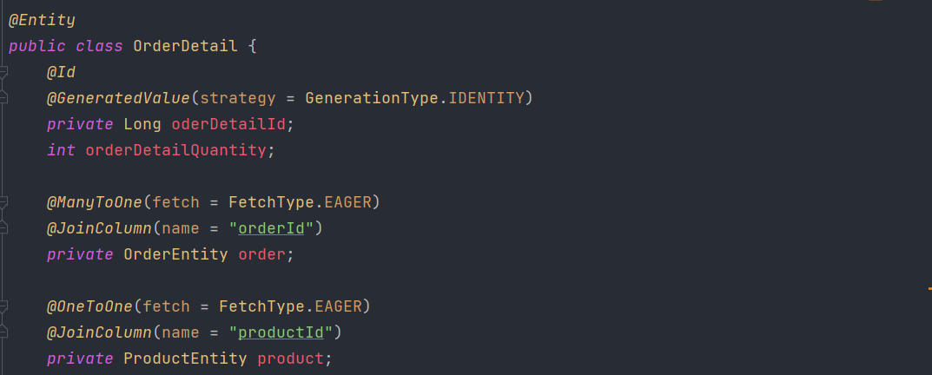

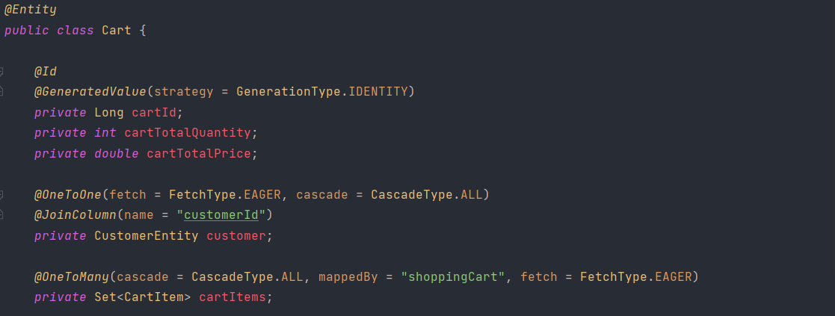

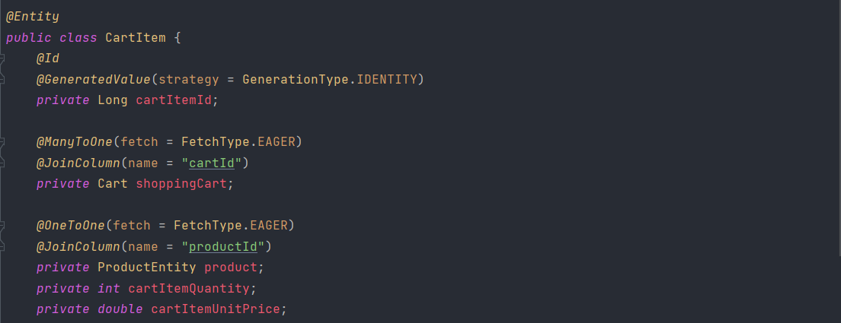

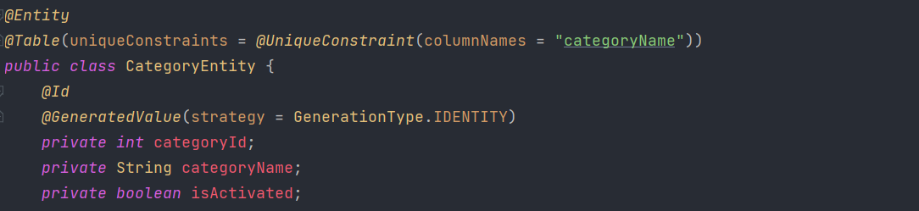

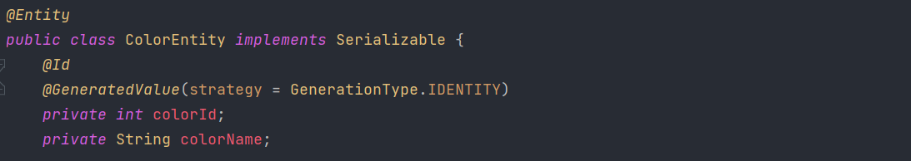

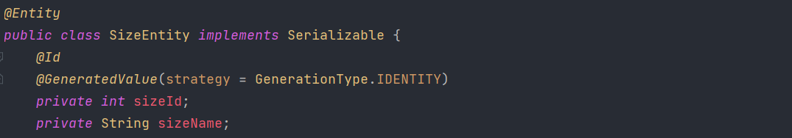

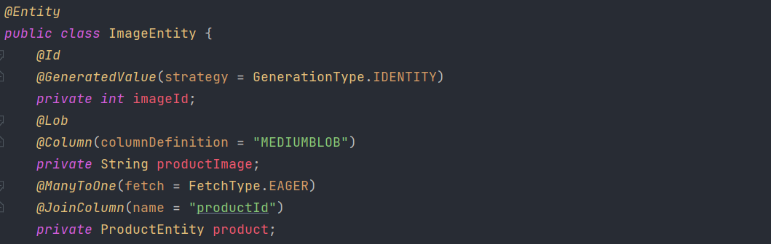

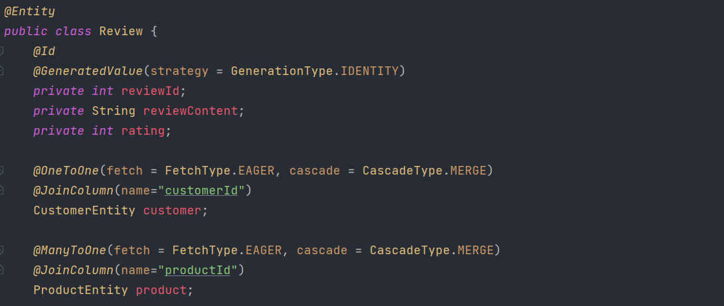

## Admin side

The admin will take care of the management section, specifically handling products, orders from customers, and product categories. The admin functionality will be developed as a separate project for easier management, running parallel with the customer-related functionalities.

### Views

The approach to solving the Admin section is to have a separate JSP file for each management part. For example, for the "category" section, there will be a "category.jsp" file, and so on.

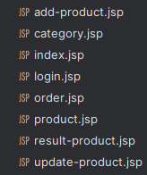

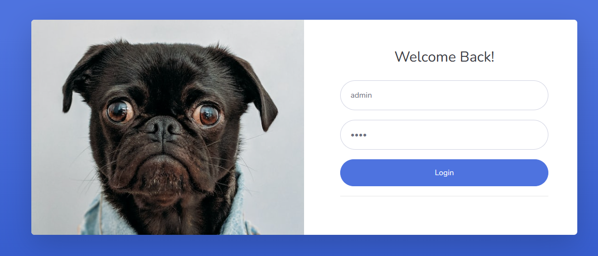

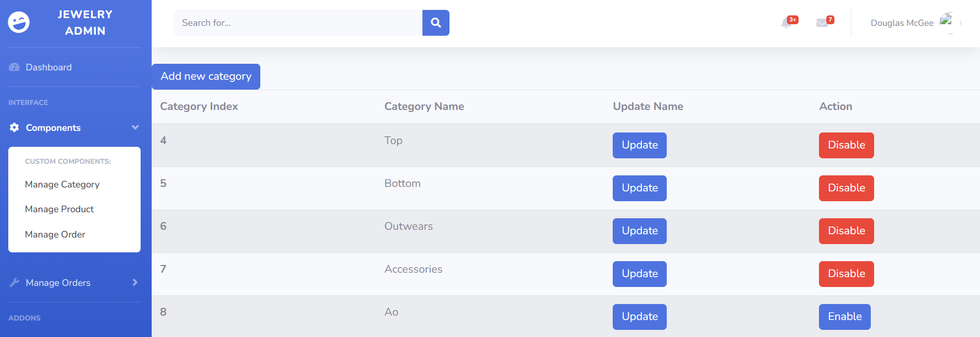

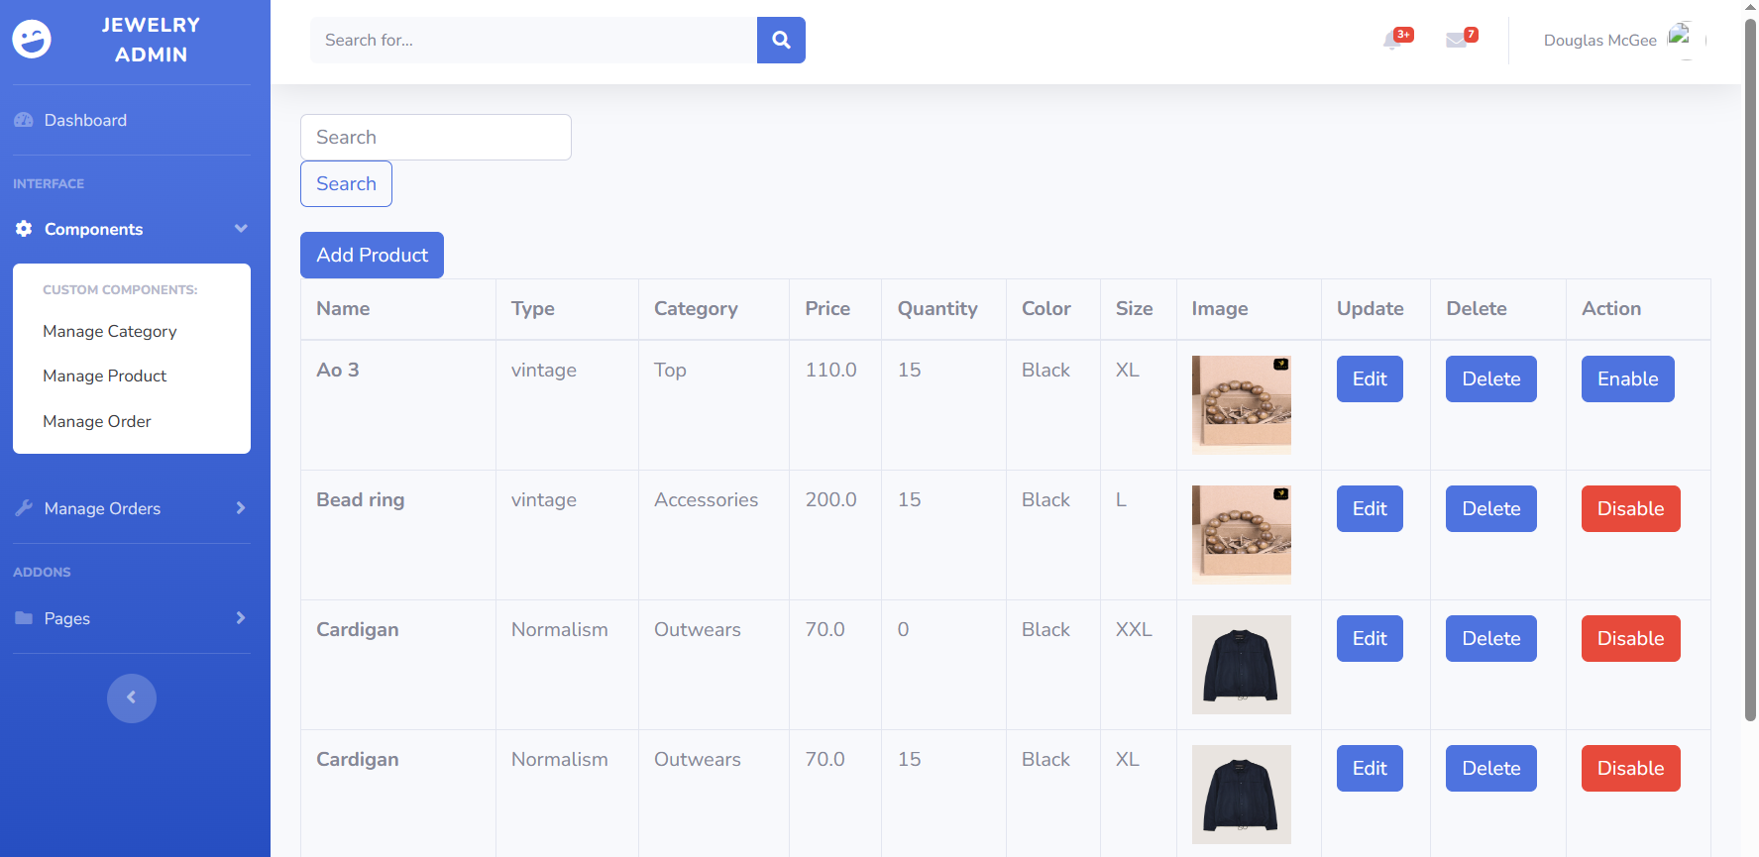

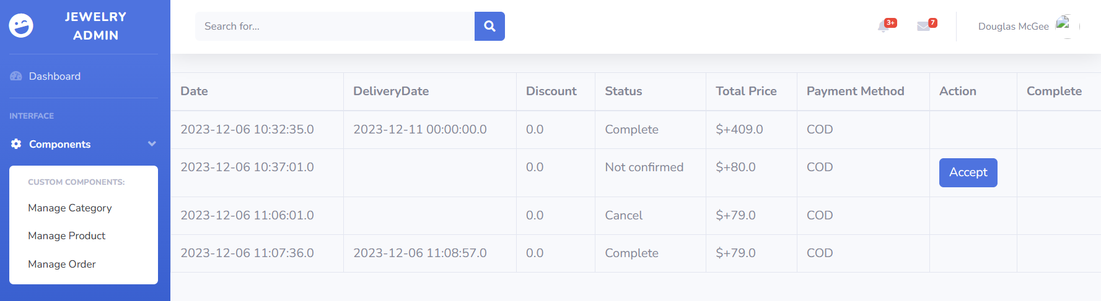

### Controller

To facilitate data input or retrieval from the JSP files, we establish separate controller files for each management section to handle requests.

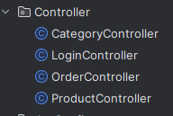

#### Login Controller

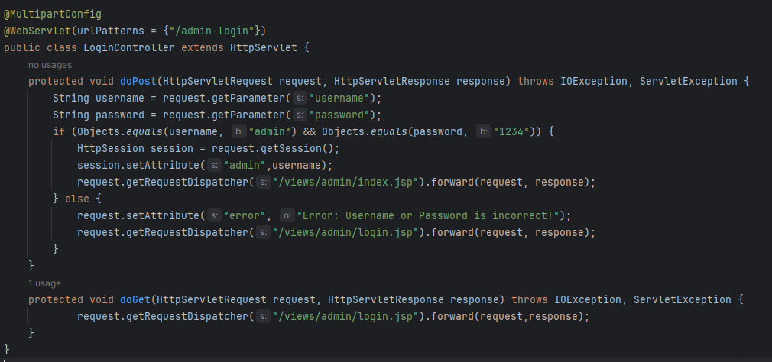

This Controller will handle the admin login functionality. It will receive a request with two values: the *username* and *password* entered by the admin. If the username is 'admin' and the password is '1234', the controller will redirect the request to the 'index.jsp' page. If the credentials are incorrect, it will generate an error and redirect to login.jsp.

#### Category Controller

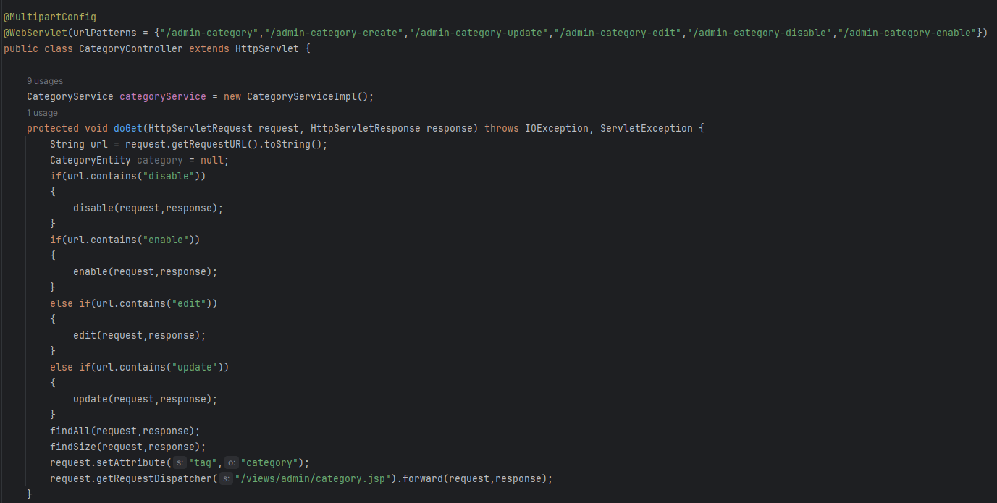

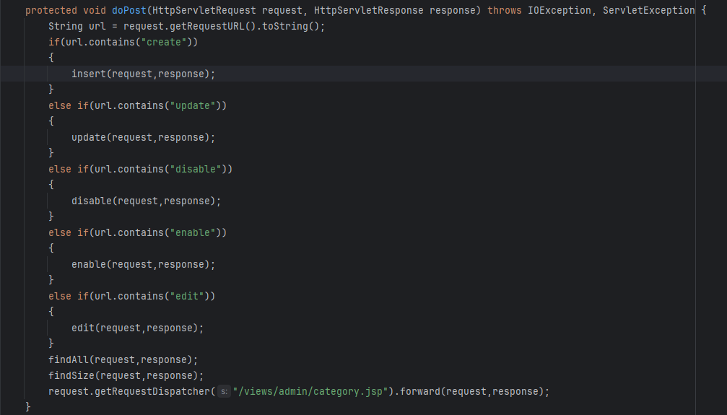

|  |  |
| --- | --- |
| Method name | Description |
| insert | This method will be executed when we add a new category. It will retrieve the name value of the category that the admin has just entered and add it to the database. Additionally, each category name must be unique, and if there is a duplication, an error message will be displayed. |
| update | This method will be executed when we want to edit the information of an existing category. Specifically, if we wish to change the name of a category, it will update the corresponding database entry. If the new name happens to match the name of another existing category, the response will return an error. |
| edit | This method will be executed when we want to edit the information of a category. It will return the details of the category that we want to edit and display them in a form presented in the JSP file. |
| enable | This method will be executed when we want to display the information of a categoryTrên cùng của Biểu mẫu to customer. |
| disable | The same as the Enable method. This method will be used for hiding the information of a category to customer. |
| findAll | This method will be executed whenever we load into the category.jsp file. It will return all categories in the database and display them on a JSP file. |
| findSize | This method will be executed correspondingly with the findAll method. It will return a count which is the size of existed category list. If the count is equal to 0, the JSP file will output a string indicating that there are no categories in the database. If it's not zero, it will display the list of categories in the "category.jsp" file. |

#### Product Controller

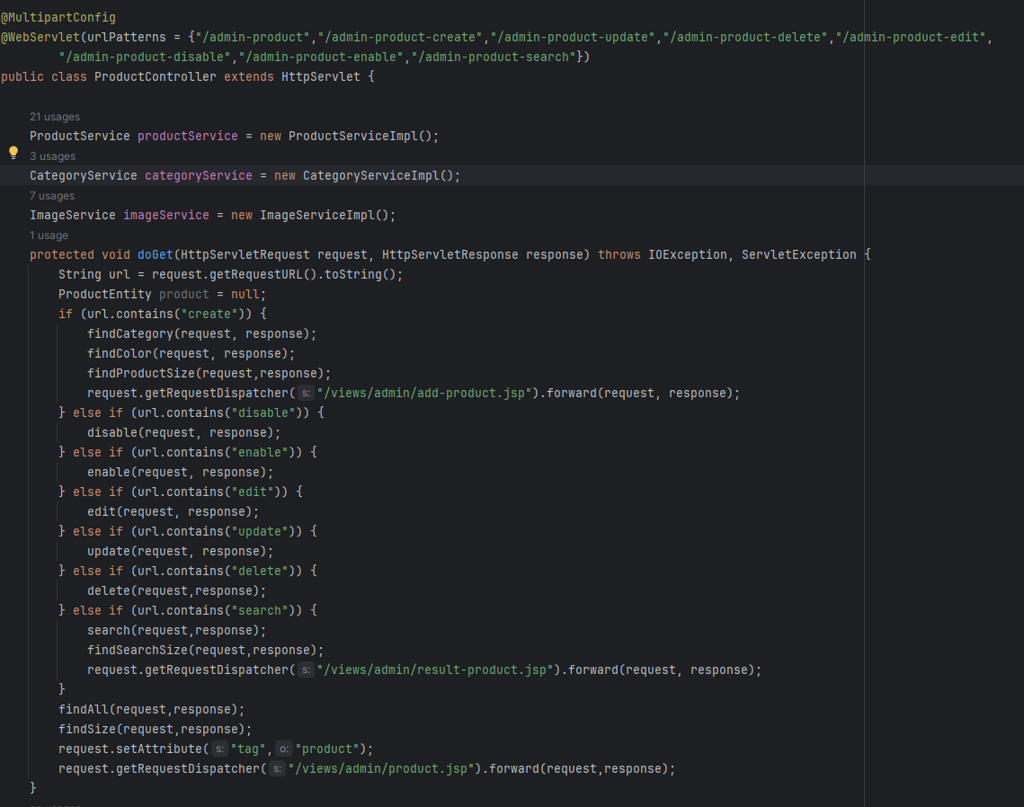

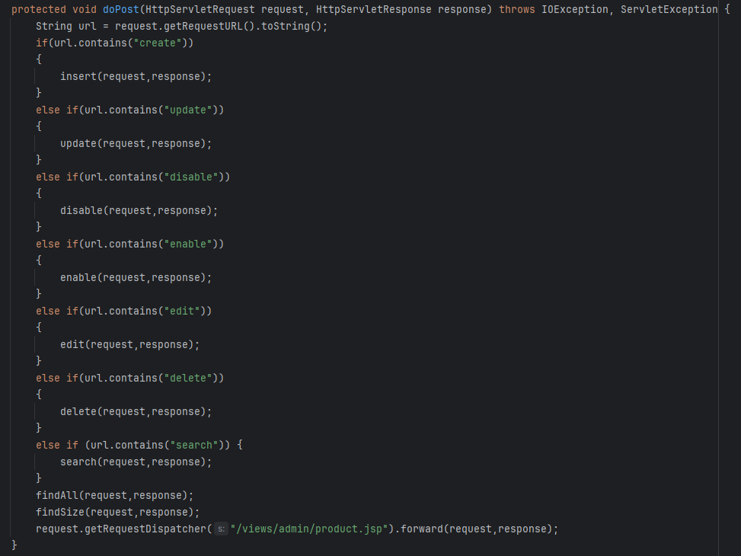

|  |  |
| --- | --- |
| Method name | Description |
| insert | This method will be executed when we add a new product. It will retrieve all the needed value of the product that the admin has just entered and add it to the database.Furthermore, each product will be uniquely identified, as a product may have multiple sizes and colors. If two products share the same combination of these three attributes and a request is made, it will result in an error. |
| update | This method will be executed when we want to edit the information of an existing product. If the updated product happens to match the another existing product, the response will return an error. |
| edit | This method will be executed when we want to edit the information of a category. It will return the details of the product that we want to edit and display them in a form presented in the JSP file. |
| enable | This method will be executed when we want to display the information of a categoryTrên cùng của Biểu mẫu to customer. |
| disable | The same as the Enable method. This method will be used for hiding the information of a category to customer. |
| delete | This method will be executed when we want to delete an exsited product. It will get the Id of that product and remove the row in product database with the coressponding Id. |
| findCategory | This method will be executed when we want to add or edit a product. It will retrieve a list of categories which is enabled from the admin. From that, we can add the product with a specific category. |
| findColor | The same as findCategory method, it will retreive a list of colors. Thus, we can add a product with a specific color. |
| findSize | The same as findCategory method, it will retreive a list of size. Thus, we can add a product with a specific size. |
| findAll | This method will be executed whenever we load into the product.jsp file. It will return all products in the database and display them on a JSP file. |
| findSize | This method will be executed correspondingly with the findAll method. It will return a count which is the size of existed product list. If the count is equal to 0, the JSP file will output a string indicating that there are no product in the database. If it's not zero, it will display the list of products in the "product.jsp" file. |

#### Order Controller

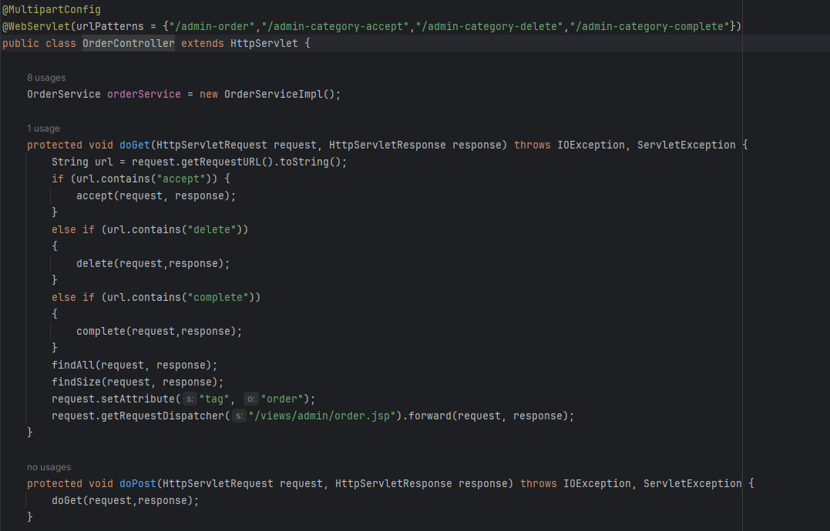

|  |  |
| --- | --- |
| Method name | Description |
| accept | This method will be executed when we accept an order. The order is made by customer, then admin will be resposible for accept order or not. If the order is accepted, its delivery date is set to the date when the order is created plus an additional 5 days and status will be set as “shipping” |
| delete | This method will be executed when the order have already been accepted and the admin want to delete it or cancel it.If an order is deleted or cancelled, its status will set to cancel. |
| complete | This method will be executed when admin want to compelete an order. It means the order has been shipped to the customer. Its status will be set to “Complete”. |
| findAll | This method will be executed whenever we load into the order.jsp file. It will return all orders in the database and display them on a JSP file. |
| findSize | This method will be executed correspondingly with the findAll method. It will return a count which is the size of existed order list. If the count is equal to 0, the JSP file will output a string indicating that there are no order in the database. If it's not zero, it will display the list of orders in the "order.jsp" file. |

### Service

Besides, within each controller, specific services are required to address tasks associated with particular methods. In this project, we adopt an interface service - a structure that outlines methods, coupled with a Java class, "serviceimpl," to execute those methods within the service interface. This approach enhances our ability to effectively manage tasks.

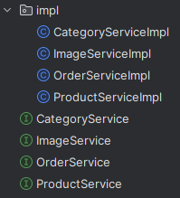

## Customer side

### Views



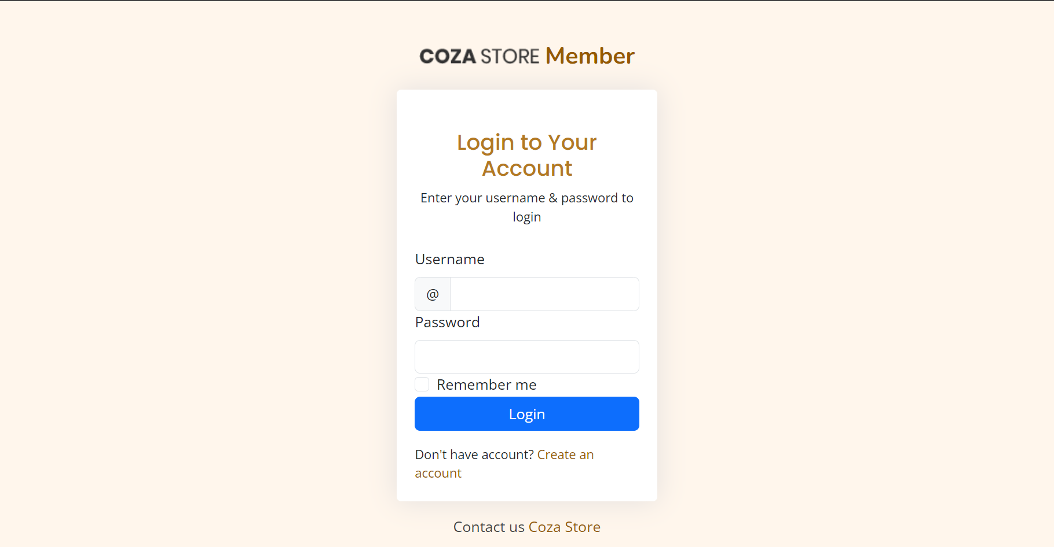

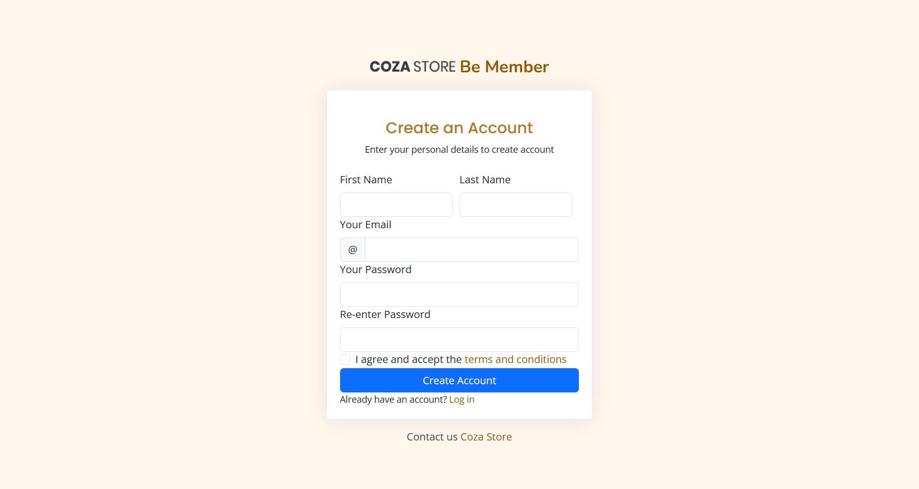

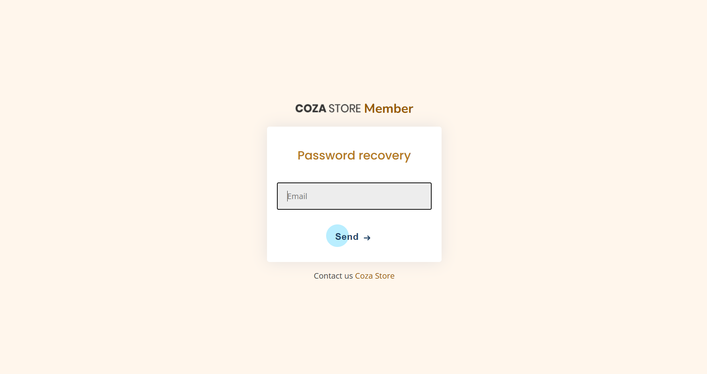

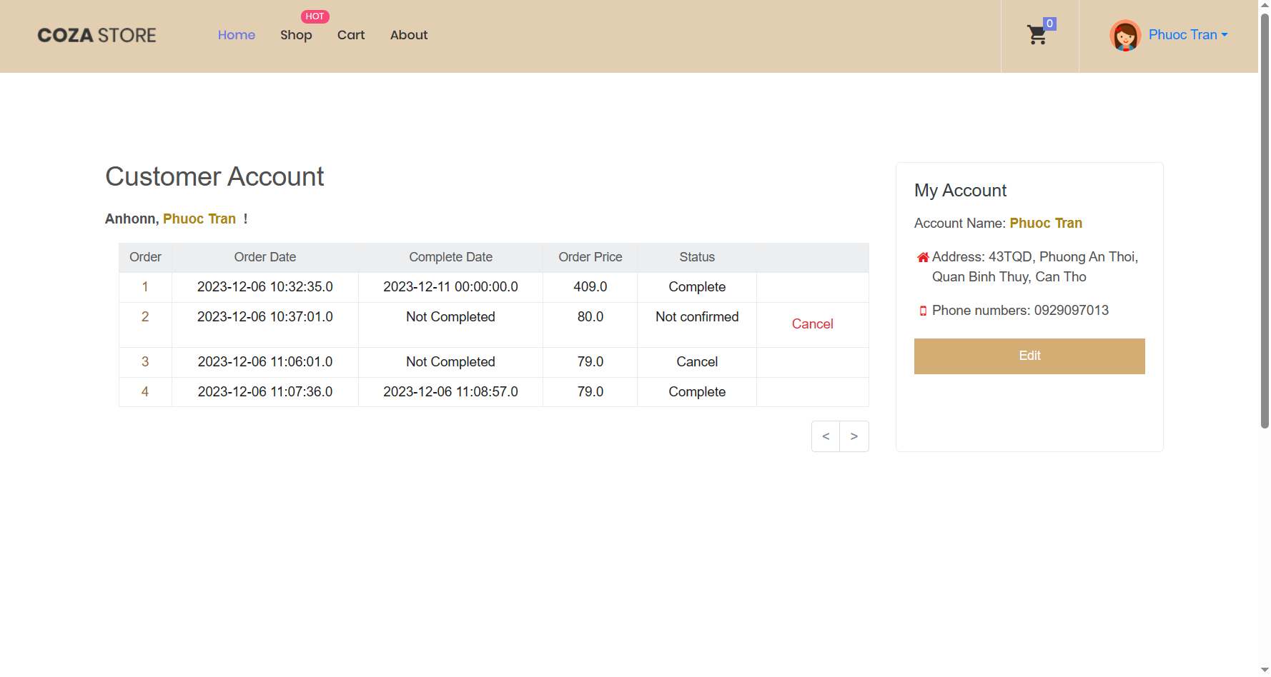

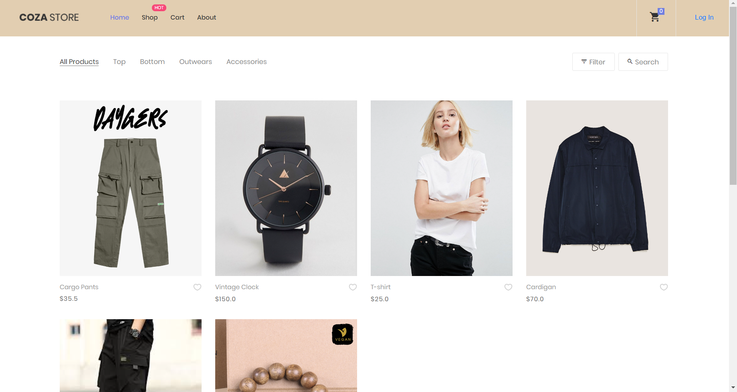

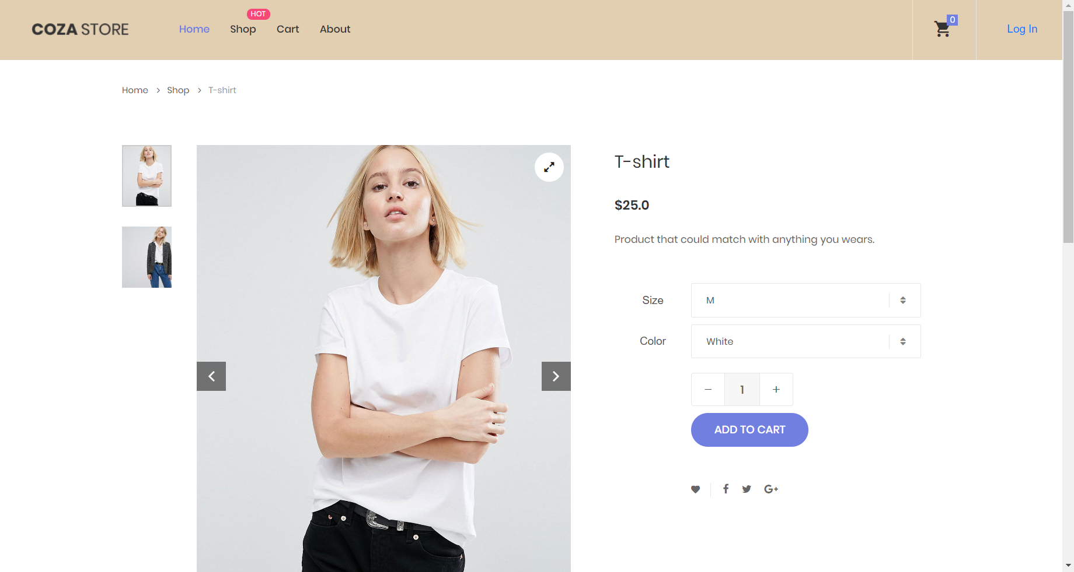

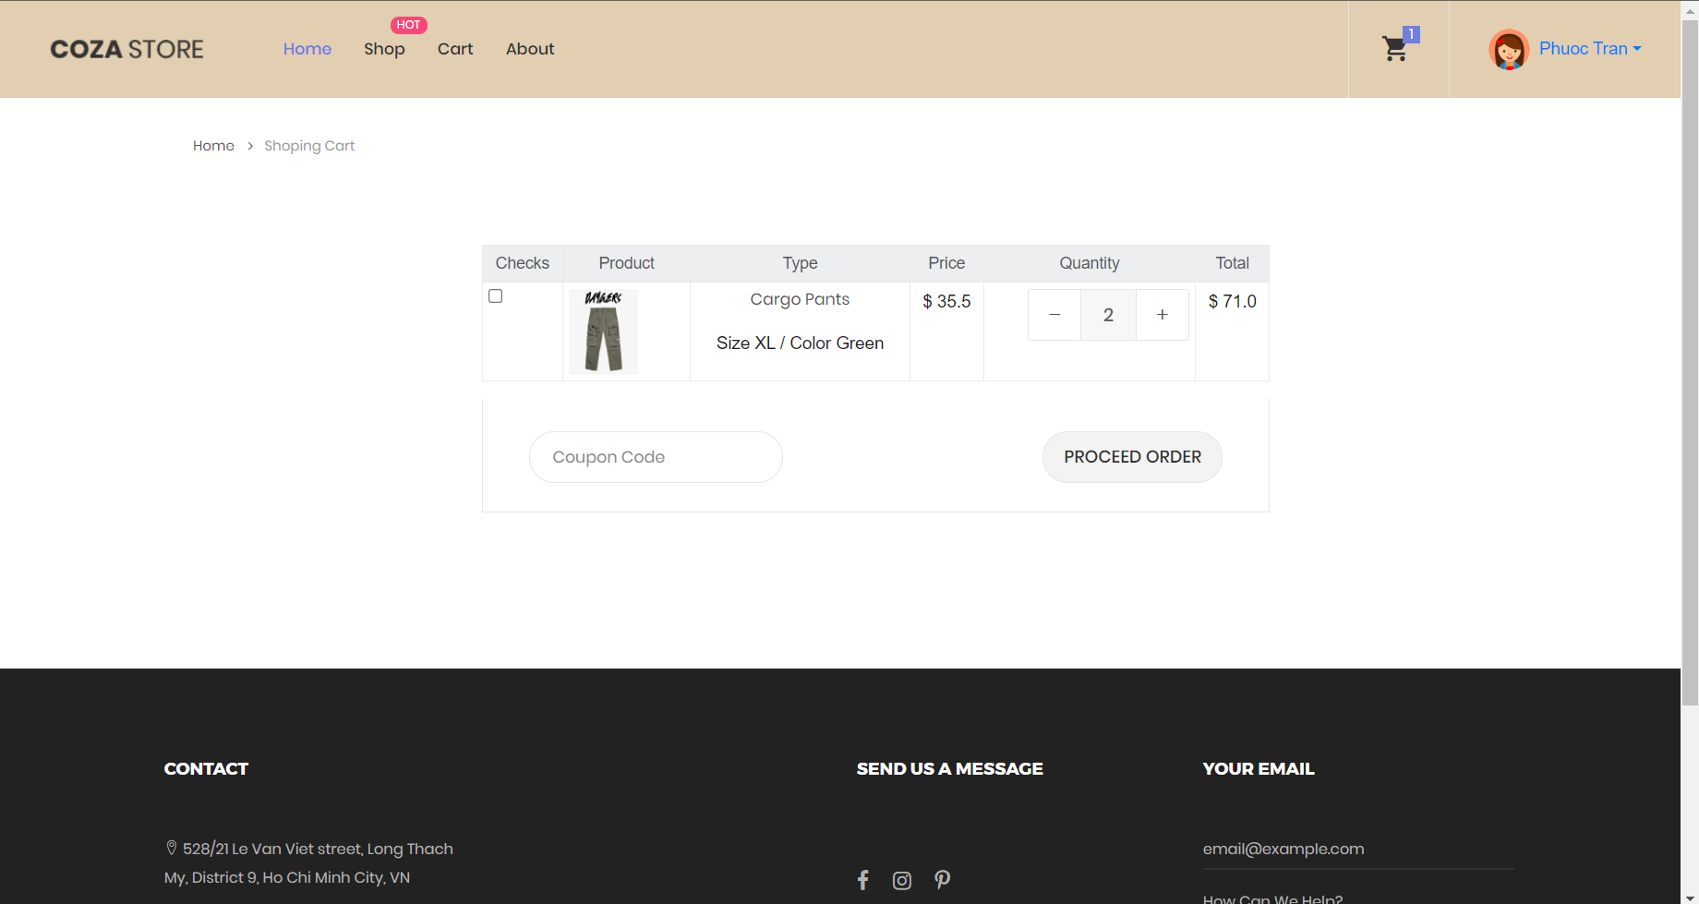

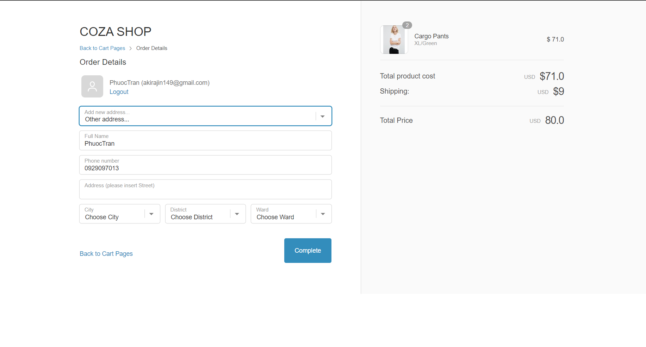

### Controller

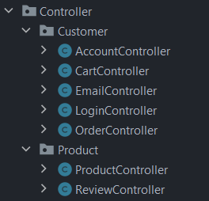

#### Account Controller

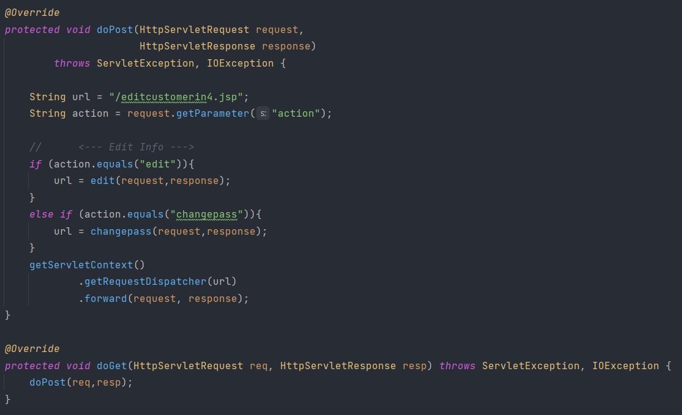

|  |  |
| --- | --- |
| Method name | Description |
| edit | Handle update user information function with provided info from JSP page. |
| changepass | Handles the process of changing the user's password. |

#### Cart Controller

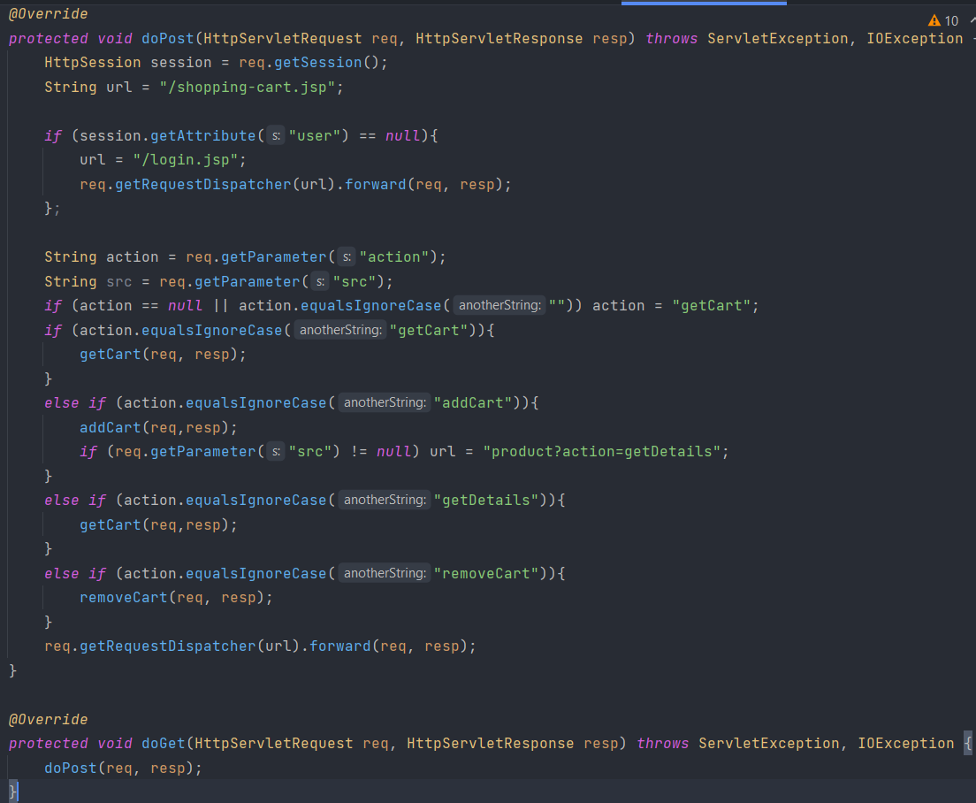

|  |  |
| --- | --- |
| Method name | Description |
| getCart | Retrieves the user's cart and associated cart items from the database based on the user session.  This is a Public Static method which means it can be call anywhere in the project due to the needs of updated rapidly through out the session of the cart. |
| addCart | Updates the cart by either adding a new item or modify the quantity of an existing item (if an item quantity is less than or equal 0 it will be removed from the cart). |
| removeCart | Manages the removal of items from the cart by id and increases the product inventory back by the removed quantity. |

#### Email Controller

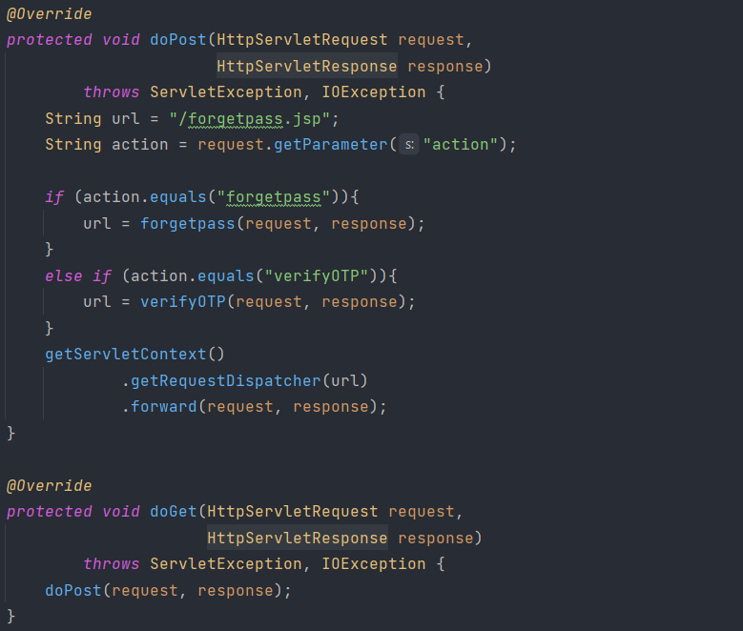

|  |  |
| --- | --- |
| Method name | Description |
| forgetpass | Processes the forget password action by generate an OTP that sending to email and required user to input and compare OTP before password can be changed. |
| verifyOTP | Handles OTP verification. Retrieves the OTP entered by the user and compares it with the OTP stored in the customer's entity. |

#### Login Controller

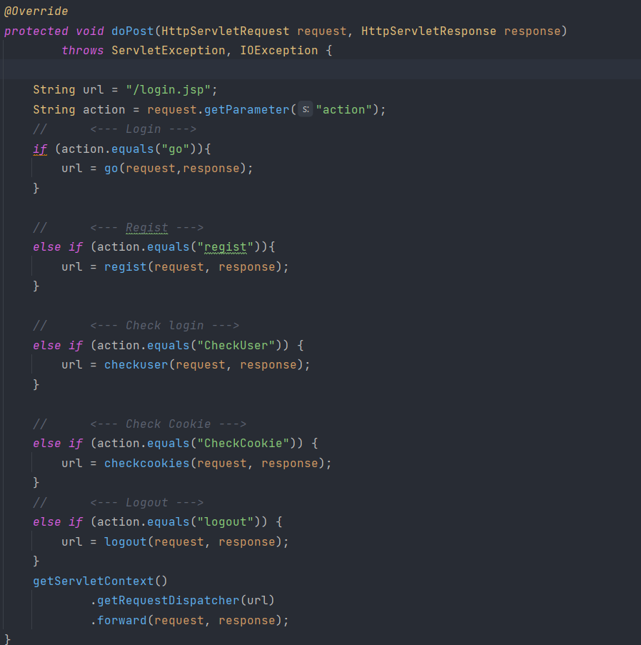

|  |  |
| --- | --- |
| Method name | Description |
| go | Processes user login.  Validates the user's credentials against the database.  If successful, sets a session attribute for the user and potentially creates a cookie if "remember" is selected. |
| regist | Handles user registration.  Persists new customer information into the database.  Sends a confirmation email to the registered email address. |
| checkUser | Checks if a user is logged in.  If the user is not logged in, checks for an email cookie. If found, retrieves user information and sets a session attribute. |
| checkCookie | Checks for user cookies.  Retrieves user information from cookies and sets a session attribute if the user is not logged in. |
| logout | Handles user logout functionality.  Deletes cookies associated with the user and invalidates the session. |

#### Order Controller

#### Product Controller

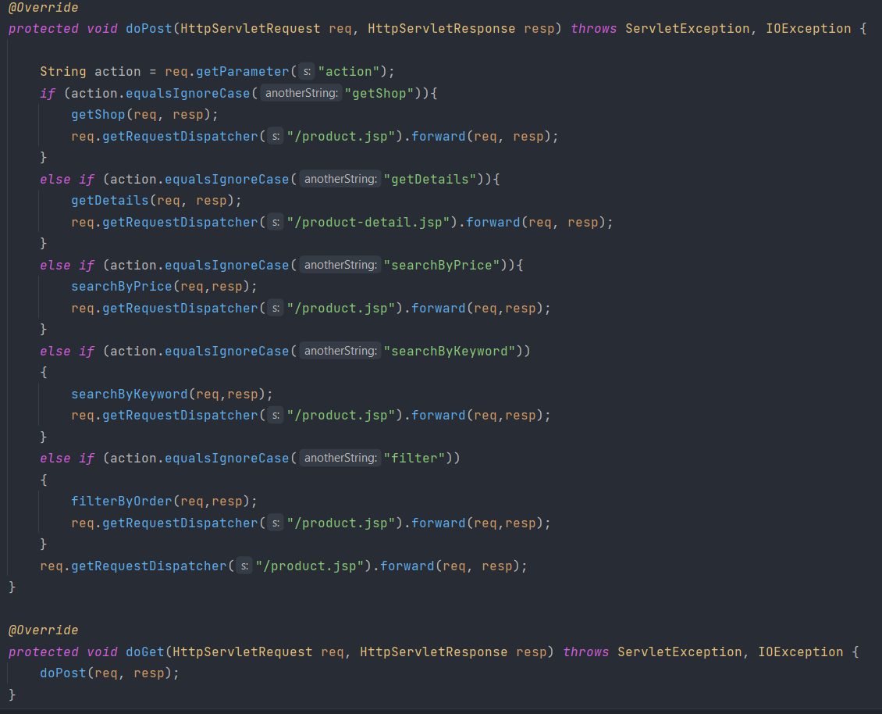

|  |  |
| --- | --- |
| **Method name** | **Description** |
| getShop | Retrieves a list of all products and active categories.  Sets attributes in the request object (categoryList, productList, productIds) to be used by the JSP page. |
| getDetails | Retrieves details for a specific product (includes reviews by calling ReviewController and product basic details) based on the provided product ID and sets attributes to the request which will display on the JSP page.  Checks if the product is out of stock and sets an attribute (isOutOfStock) accordingly. |
| searchByPrice | Retrieves products within a specified price range provided in the request and return a product list that in a price range. |
| searchByKeywords | Retrieves products based on a keyword provided in the request and set these to the request object. |
| filterByOrder | Filters products based on selected product IDs and a sorting flag (ascending/ descending) and set the filtered product list to display on JSP page. |

#### Review Controller

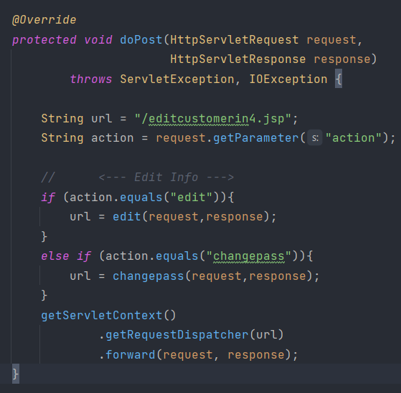

|  |  |
| --- | --- |
| **Method name** | **Description** |
| edit | Creates a new Review object for a product (if user has logged in bought the product) and inserts it into the database based on provided information (customer info and product info). |
| changepass | Retrieves reviews for a specific product and necessary information for the JSP page to implements. |

### Service

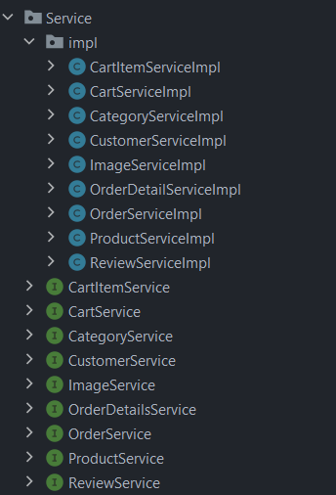

Besides, within each controller, specific services are required to address tasks associated with particular methods. In this project, we adopt an interface service - a structure that outlines methods, coupled with a Java class, "serviceimpl," to execute those methods within the service interface. This approach enhances our ability to effectively manage tasks that interact with model rather than interact directly from Controller.

# GROUP CONCLUSION

## Task manager

|  |  |  |
| --- | --- | --- |
| Members | Task | Evaluation |
| Cao Thái Đạt | Entire admin form  Filter, search in product  Implement database | COMPLETE |
| Trần Bình Phước | Implement database  Making function of product, cart, orders and review. | COMPLETE |
| Trần Đức Quang | Making entire front-end of customer UI  Making function of customer account (register, login, forgot password, email sending, …) | COMPLETE |

## Pros and cons of the project

Pros:

* Complete the basic function of the given project.
* Does include dynamic function
* Eyes catching UI.

Cons:

* Product implementation logic is still not correctly (At color and size).
* Due to using servlet the application is still quite slow.

## Chalenges and difficulties

Challenges and difficulties.

Because this project uses JavaServlet, there are many online resources and documentation available for developing a project using JavaServlet, JSP, and Java. Therefore, it's not very challenging to work on this web project. The only obstacle is the abundance of information, which can make debugging time-consuming. There are often multiple ways to debug the same type of error, and dealing with a low-end API means that built-in features are limited. This results in writing more code, and optimizing the code can be time-consuming and demanding.

However, this learning process provides valuable insights, and when transitioning to a higher-level API like Spring Boot, the execution will likely be more efficient.

# REFERENCES

[1] Murach’s Java Programming (6th Edition). From: <https://www.murach.com/shop/murach-s-java-programming-6th-edition-detail>

[2] Inteliji tutorial. From <https://www.youtube.com/@intellijidea>

[3] Coza Store Bootrap copyright. From: <https://themewagon.com/themes/free-html5-ecommerce-website-template/>

**END**